02/10/2026

Dear Parents and Community Members:

We are pleased to present you with the Annual Education Report (AER), which provides key information on the 2024-25 educational progress for Jalen Rose Leadership Academy. The AER addresses the complex reporting information required by federal and state laws. The school’s report contains information about accountability, student assessment, and teacher quality. If you have any questions about the AER, please contact Melissa Ross for assistance.

The AER is available for you to review electronically by visiting the following link: https://bit.ly/4ceuyd4 For the 2025-26 school year, schools were identified based on previous years’ performance using definitions and labels as required in the Every Student Succeeds Act (ESSA). A Targeted Support and Improvement (TSI) school is one that had at least one underperforming student group in 2024-25. An Additional Targeted Support (ATS) school is one that had at least one student group performing at the same level as the lowest 5% of all schools in the state in 2021-22. A Comprehensive Support and Improvement (CSI) school is one whose performance was in the lowest 5% of all schools in the state, had a graduation rate at or below 67%, failed to exit CSI status in 2024-25, or failed to exit ATS status in 2021-22. Some schools are not identified with any of these labels. In these cases, no status label is given.

Our school was not Identified with any of these labels.

CHALLENGES:
At Jalen Rose Leadership Academy, our key challenges have been:
- To move scholars to the level of rigor expected for post-secondary excellence. Often, our scholars enter high school with academic scores below the state & national averages for P/SAT assessments; our scholars are below grade level in reading and math.
- The # of Chronically Absent students

INITIATIVES,:
As a result, we implemented key initiatives to accelerate scholar learning and increase academic achievement:
- Interim assessments that lead to reteaching and re-assessment of standards
- Daily SAT-aligned Do Now questions
- 4 years of math courses with differentiated support
- Pre-AP Courses ensuring that scholars are engaged in curriculum and assessment tasks focused on academic conversations, evidenced based writing, higher order questioning, and observation and analysis.
- College Bound Scholars Course (CBS) to help scholars focus on both hard academic skills and soft skills Office Hours for additional teacher support after school
- CTE and Dual Enrollment courses to increase rigor, promote career readiness and increase engagement.
- Strict Attendance Policy
- More Rigorous Grading Policy

State law requires that we also report additional information:

PROCESS FOR ASSIGNING PUPILS TO THE SCHOOL
JRLA scholars are admitted to the school through an open enrollment process by the order in which they apply. By law, JRLA cannot restrict enrollment based on selection criteria. JRLA can, however, limit the total number of scholars who may attend the school. If there are more applicants than open spaces during the open enrollment period, scholars are then admitted through a random selection process.

THE STATUS OF THE 3-5 YEAR SCHOOL IMPROVEMENT PLAN:
Jalen Rose Leadership Academy has just gone through an entire lift of its administrative team and has revamped the school improvement plan. It is in its second year of the current school improvement plan.

DESCRIPTION OF THE SCHOOL:
Jalen Rose Leadership Academy (JRLA) is a College Preparatory Public Charter School that provides a leadership-focused education that engages and inspires youth to achieve at the rigorous level necessary to ultimately graduate with a college degree or post-secondary program. Scholars engage with grade level content designed to prepare them for college and post-secondary pursuits. JRLA provides a full continuum of services for those scholars who have been deemed eligible for Special Education Placement.

HOW TO ACCESS A COPY OF THE CORE CURRICULUM, A DESCRIPTION OF ITS IMPLEMENTATION, AND AN EXPLANATION OF THE VARIANCES FROM THE STATE’S MODEL
The school's curriculum objectives are aligned to those identified by the Michigan High School
Content Expectations, as well as the College Readiness Standards for P/SAT. For more information, please email: Kelly Smith, smithke@jrladetroit.com.

The Michigan high school graduation requirements are designed to prepare scholars for college or other post-secondary studies if satisfactorily completed. JRLA not only incorporates the state
standards, but also incorporates P/SAT College Readiness standards to help blend preparation for
college. Our P/SAT College Readiness Standards are used to determine mastery of a subject at each grade level.
JRLA offers high school courses aligned to the state of Michigan: four credits of English, four years of mathematics, three years of social studies, three years of science, two years of foreign language, one year of physical education and fitness, one year of arts education. Promotion policies and exit
standards have traditionally exceeded the minimum state requirements and have stressed the importance of a well-rounded education.

THE AGGREGATE STUDENT ACHIEVEMENT RESULTS FOR ANY LOCAL COMPETENCY TESTS OR NATIONALLY NORMED ACHIEVEMENT TESTS
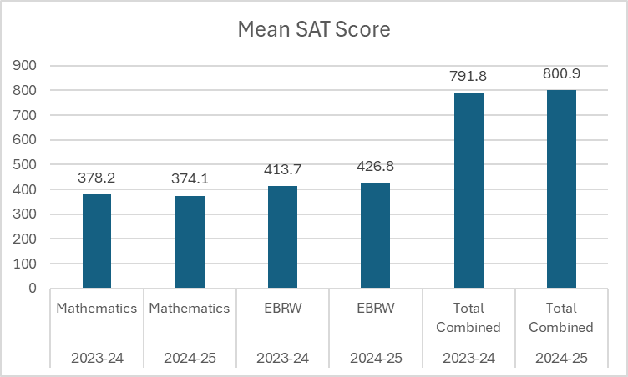

Conference Attendance: Attendance at our first quarter conference for 2025–2026 reached 255 parents (65% of families), a significant increase over the 195 parents (48%) who attended in 2024–2025. This growth also surpasses the 2023–2024 average of 196 parents (48%).
Postsecondary Enrollment: In 2024-2025, we offered 6 different dual enrollment courses and had 116 students or 29% enrolled. 100% of those students passed and received college credit. In 2023-2024. 409 scholars or 100% of our students were given the chance to earn 1 leadership college credit through Wayne State University
AP Courses: In 2024-2025. JRLA offered 2 AP courses with 27 enrolled and 9 or 33% received a score that led to college credit. In 2023-2024, JRLA offered 2 AP courses with 42 enrolled and 10 or 4% received a score that led to college credit.

Together, our scholars, families, and staff continue to demonstrate what is possible when a community commits to respect, family, determination, and excellence. The progress highlighted in this report reflects not only academic growth, but the character and leadership our students are developing every day. I am proud of the resilience, effort, and belief our scholars show in themselves and in one another. As we look ahead, we remain focused on continuous improvement and on preparing every student for success in college, career, and life. Thank you for your partnership and trust in Jalen Rose Leadership Academy; we are excited about the future we are building together.
Sincerely,
Jazmine Allen
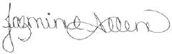
Principal

