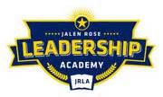

Jalen Rose Leadership Academy
Collective Bargaining Agreements Transparency Report
FY 2017-2018

The District does not have any collective bargaining agreements for the fiscal year 2017-2018.

