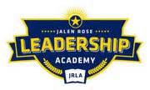

Jalen Rose Leadership Academy
Travel Information Transparency Report
FY 2018-2019

No travel to report.

