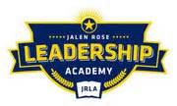

Jalen Rose Leadership Academy
Credit Card Information Transparency Report
FY 2018-2019

The District currently does not issue credit cards to staff members. However the district does issue one debit card. See information below:
Card Type | User’s Limit | Authorized User | Last 4 Digits
Master Card | N/A | Tara Dari | 4855

